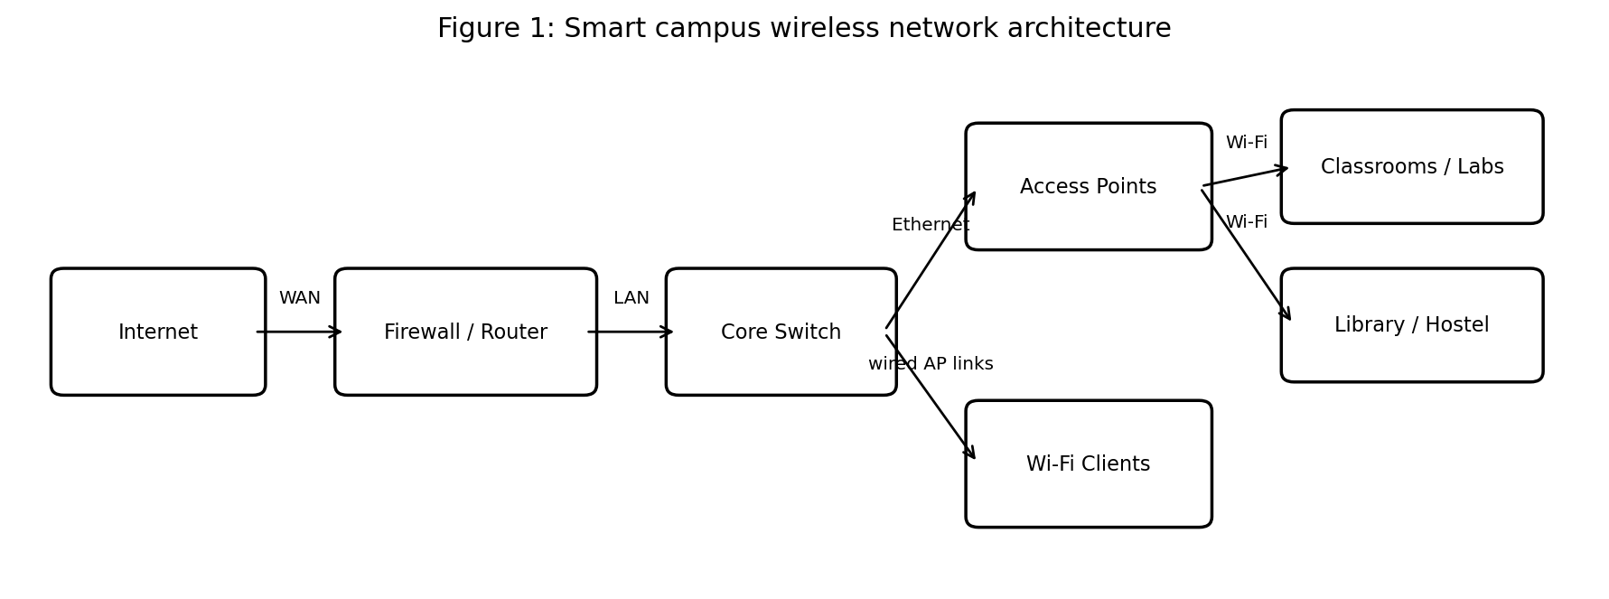
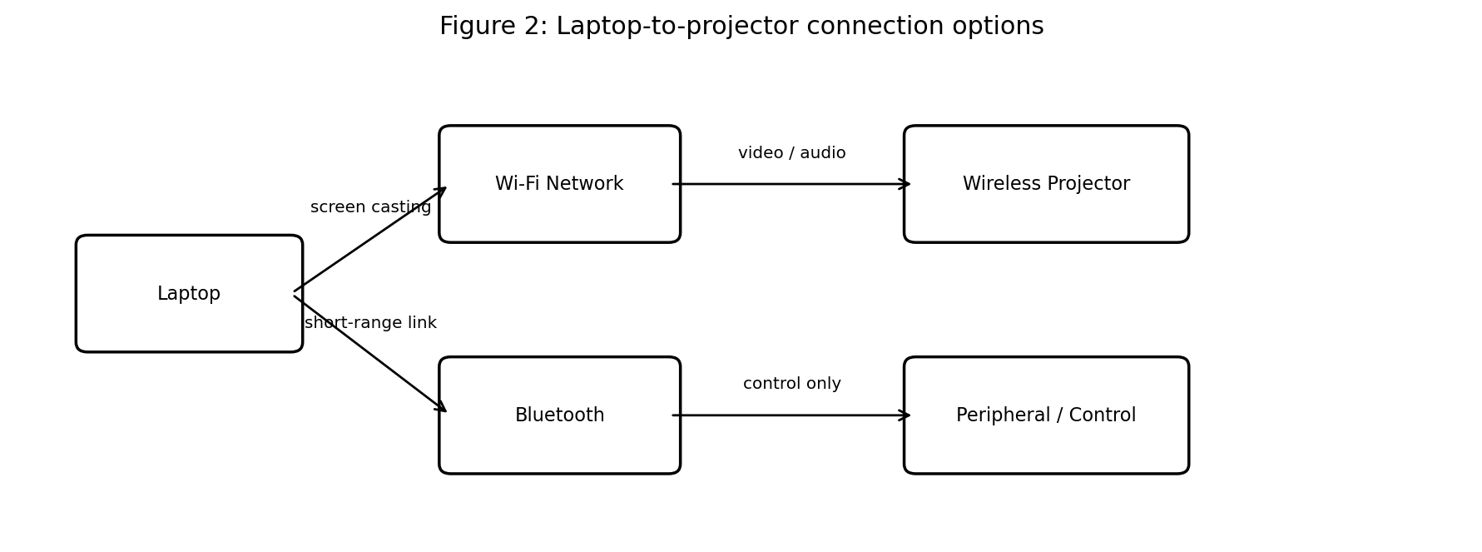
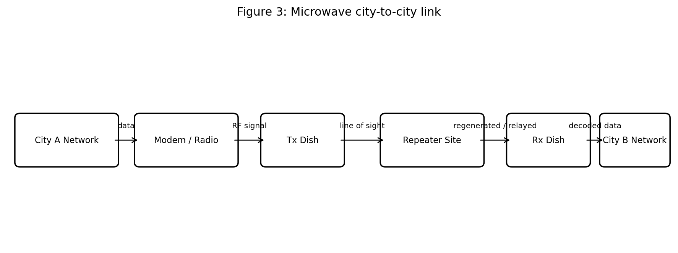
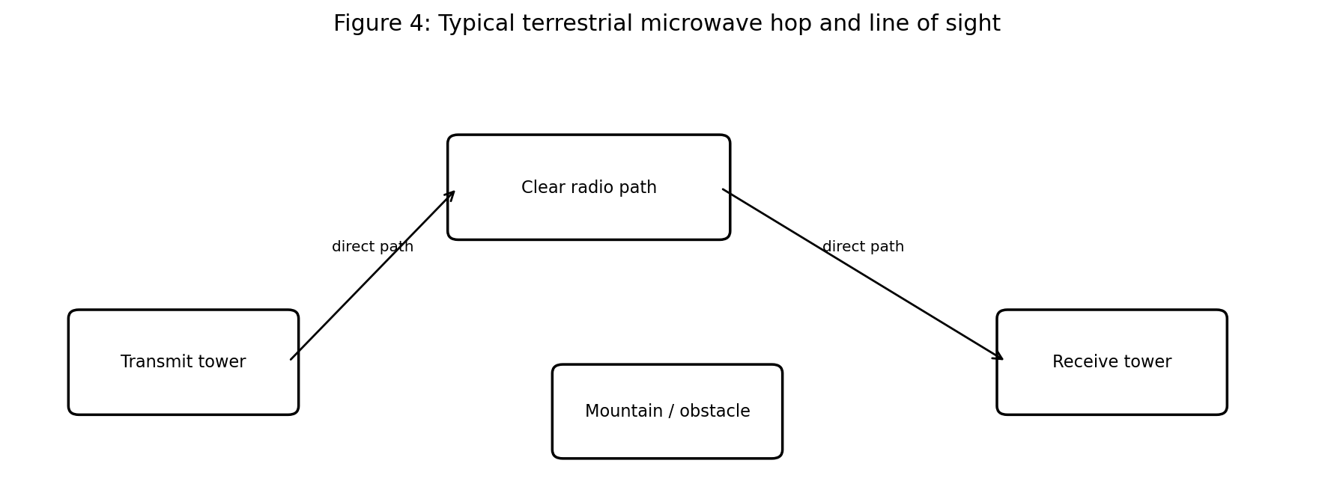
LAKSHMI NARAIN COLLEGE OF TECHNOLOGY (MCA)
BHOPAL
MCA – I SEMESTER
INFORMATION TECHNOLOGY
Subject Code: MCA-104
ASSIGNMENT – UNIT I (CO-I)
Topic 1: Smart College Campus Using Wi-Fi and Bluetooth
Topic 2: Communication Between Two Cities Using Microwave Systems
Submitted by: __________________________________
Roll Number: ____________________________________
Section: _________________________________________
Submitted to: ____________________________________
Academic Session: 2026–2027

DECLARATION
I hereby declare that this assignment for MCA-104 (Information Technology), Unit-I, has been prepared for academic learning. The explanations, examples and diagrams are presented to demonstrate my understanding of wireless networking and microwave communication systems. Any values or scenario details used as examples are illustrative and should not be interpreted as measurements from an actual LNCT installation.

ACKNOWLEDGEMENT
I would like to express my thanks to the faculty of the MCA programme for providing this assignment. Preparing it has helped me connect communication-system concepts with practical campus networking and inter-city telecommunications. I have organised the material around the two case studies stated in the assignment sheet and included block diagrams to make the system flow easier to understand.

HOW TO USE THIS ASSIGNMENT
The supplied assignment sheet presents Case Study 1 OR Case Study 2. This document contains complete draft answers for both alternatives so that the student can study either one. Before submission, confirm with the subject teacher whether only one case study is required. If the instruction is to answer only one, retain that case study and remove the other section.

CONTENTS
1. Introduction to Communication Systems
2. Case Study 1 — Smart College Campus Using Wi-Fi and Bluetooth
2.1 Problem statement and objectives
2.2 Wi-Fi campus architecture and working
2.3 Bluetooth technology and working
2.4 Wi-Fi versus Bluetooth
2.5 Laptop-to-projector recommendation
2.6 Combined campus services
2.7 Wireless limitations and mitigation
2.8 Deployment plan, security and testing
3. Case Study 2 — Communication Between Two Cities Using Microwave Systems
3.1 Problem statement and requirements
3.2 Microwave working principle
3.3 Line-of-sight and Fresnel zone
3.4 Antennas, repeaters and system blocks
3.5 Microwave versus radio and fibre
3.6 Recommendation, advantages and limitations
3.7 Planning, reliability and maintenance
4. Comparative summary
5. Conclusion
6. Glossary
7. References

1. INTRODUCTION TO COMMUNICATION SYSTEMS
A communication system transfers information from a source to a destination through a medium. The information may be text, voice, video, sensor readings or computer data. A basic system contains a source, transmitter, communication channel, receiver and destination. The transmitter converts information into a signal suitable for the channel; the receiver extracts the information from the received signal.
Communication links may be wired or wireless. Wired systems use a physical medium such as copper cable or optical fibre. Wireless systems use electromagnetic waves through space. Wi-Fi, Bluetooth, terrestrial microwave and cellular systems are examples of wireless communication, but they are designed for different distances, data rates, power budgets and deployment conditions.
The first case study combines Wi-Fi, which is suited to local-area networking and internet access, with Bluetooth, which is suited to short-range device-to-device connections. The second case study considers terrestrial microwave links, which can carry high-capacity traffic between fixed sites when a suitable radio path is available.

Objectives of this assignment
- Explain the end-to-end operation of a campus Wi-Fi network and the role of Bluetooth.
- Compare Wi-Fi and Bluetooth in terms of range, data transfer, energy use and applications.
- Choose a suitable connection method for a laptop and wireless projector.
- Explain the operation and design constraints of a terrestrial microwave link.
- Compare microwave communication with general radio communication and fibre-optic communication.
- Use block diagrams, examples and practical recommendations to support the explanation.

2. CASE STUDY 1 — SMART COLLEGE CAMPUS USING WI-FI AND BLUETOOTH

2.1 Problem statement and objectives
An MCA college requires reliable internet in classrooms, computer laboratories, libraries and hostels. Students use laptops and smartphones for learning-management systems, research, online classes and submissions. Faculty members need to connect wireless projectors, keyboards, headphones and smartphones. The administration must support many devices without compromising security or performance.
The system should provide broad campus coverage, sufficient capacity during busy periods, secure authentication, manageable access points and a practical way to connect nearby peripherals. Wi-Fi and Bluetooth are complementary rather than interchangeable technologies: Wi-Fi is the main access network, while Bluetooth is primarily a personal-area connection for compatible devices.

System requirements
- Coverage: learning spaces, offices, library, laboratories and hostel common areas.
- Capacity: multiple concurrent users, especially during class changes and examination periods.
- Performance: adequate throughput and latency for learning portals, video meetings and presentations.
- Security: authenticated users, encrypted wireless traffic, guest access separation and network monitoring.
- Manageability: central configuration, monitoring, updates and fault diagnosis.
- Compatibility: support for common laptops, smartphones, printers, projectors and Bluetooth peripherals.

Proposed design
The recommended design uses an internet connection connected to a firewall/router, followed by a campus core switch and wired Ethernet links to ceiling-mounted Wi-Fi access points. Access points broadcast one or more network names (SSIDs). Student, faculty, administrative and guest traffic can be separated using VLANs and access-control rules. Bluetooth is enabled on individual devices for nearby accessories and selected proximity services.
Figure 1 shows the logical architecture. In a real installation, access-point placement and quantity must be determined by a site survey, building materials, user density and measured radio interference.

2.2 How Wi-Fi provides wireless internet connectivity
Wi-Fi is a family of wireless local-area networking technologies based on IEEE 802.11 standards. An access point (AP) provides a radio connection between wireless clients and the wired local-area network. The AP does not itself create internet service; it bridges or routes client traffic into the campus network, which reaches the internet through the firewall/router and internet service provider.

Step-by-step working
- A device such as a laptop scans for available Wi-Fi networks and detects the campus SSID advertised by nearby access points.
- The user selects the appropriate SSID. For a secured network, the device authenticates using the configured method, preferably enterprise authentication for staff and students where infrastructure supports it.
- After authentication, the network assigns an IP address, commonly through DHCP. The device also learns network settings such as the default gateway and DNS servers.
- When the user opens a website, the laptop sends packets over the Wi-Fi radio link to the access point.
- The access point forwards the traffic through Ethernet to the campus switch. VLAN and access-control policies determine which internal services the traffic can reach.
- The firewall/router applies security policies and sends permitted internet traffic to the ISP. Responses return through the same general path to the laptop.
- Roaming allows a moving device to transfer its connection between suitably configured access points. The client and network decide when and how to roam; good design reduces interruptions.

Role of major components
- Internet service provider (ISP): supplies the external internet connection.
- Firewall/router: connects networks, routes packets, applies security rules and may provide VPN services.
- Core/distribution switch: interconnects access points and servers; VLANs help separate traffic.
- Wi-Fi access point: provides radio coverage and bridges wireless clients to the LAN.
- Authentication service: validates identities and can apply user or device access policies.
- DHCP and DNS services: provide IP configuration and translate domain names into IP addresses.
- Network monitoring: tracks availability, interference, client load, firmware status and security events.

Frequency bands and performance
Wi-Fi commonly operates in the 2.4 GHz and 5 GHz bands, with newer equipment also supporting 6 GHz where regulations and devices permit. The 2.4 GHz band often provides better propagation through obstacles but has fewer non-overlapping channels and may experience more interference. Higher-frequency bands can provide more capacity, but signal attenuation and wall loss may be greater. Actual speed depends on the Wi-Fi generation, channel width, signal quality, client capability, interference and the wired backhaul.

2.3 Bluetooth technology and working
Bluetooth is a short-range wireless technology intended to connect devices in a personal area. Common uses include keyboards, mice, headphones, speakers, wearables and exchanging small amounts of data between compatible devices. Bluetooth operates in the 2.4 GHz ISM band and uses techniques designed to share spectrum with other devices.

Typical connection process
- Devices enable Bluetooth and discover nearby devices or advertise a service, depending on the Bluetooth mode.
- The user selects a device or the devices follow a previously configured pairing procedure.
- Pairing establishes security credentials when supported and required. Depending on the device and profile, a confirmation or PIN may be needed.
- After connection, the devices use an appropriate Bluetooth profile or service, such as a keyboard/mouse profile or an audio profile.
- Data is exchanged over the established link. When the task finishes, the connection may remain available, enter a low-power state or disconnect.

Bluetooth Classic and Bluetooth Low Energy
Bluetooth Classic is commonly used for continuous audio and some traditional accessory connections. Bluetooth Low Energy (BLE) is designed for low-energy communication and is widely used by sensors, beacons, fitness devices and smart accessories. BLE devices can advertise small data packets and may allow a phone to detect proximity or retrieve sensor values without maintaining a high-throughput continuous connection.

Examples on campus
- A faculty member connects a Bluetooth keyboard to a tablet while teaching.
- A student uses Bluetooth headphones to listen to recorded lectures.
- A laboratory may use BLE sensors to report temperature or equipment status.
- An optional library service could use BLE beacons to support opt-in indoor wayfinding, subject to privacy and accessibility review.
- Bluetooth can support device setup and control, but it is not a substitute for the campus internet access network.
Bluetooth range varies substantially with device class, transmit power, antenna design, obstacles and interference. It is generally designed for nearby devices, not for providing whole-building or campus-wide internet coverage.

2.4 Difference between Wi-Fi and Bluetooth
Wi-Fi and Bluetooth both use radio waves, but their design goals differ. Wi-Fi is optimised for local network connectivity and comparatively high throughput. Bluetooth is optimised for convenient short-range links and, particularly with BLE, low energy use.
Basis | Wi-Fi | Bluetooth | Typical use | Design implication
Primary purpose | Connect devices to a LAN/internet | Connect nearby devices/peripherals | Wi-Fi: online learning; Bluetooth: headphones | Use each for its intended job
Range | Often tens of metres indoors; can be more outdoors | Usually nearby; range varies by device and mode | Room/building vs personal area | Survey coverage instead of assuming a fixed range
Data transfer | Usually higher throughput; suitable for video and internet traffic | Usually lower throughput than Wi-Fi; varies by version/profile | Streaming and file access vs accessories/sensors | Do not use Bluetooth as the primary internet network
Power consumption | Can be higher, especially during sustained high data use | Often lower for small or intermittent exchanges; BLE is designed for low power | Laptop network vs battery sensor | Select based on device battery and traffic
Infrastructure | APs, switches, router and internet connection | Bluetooth radios in the communicating devices; gateways may be used for sensor systems | Campus infrastructure vs direct device links | Wi-Fi requires planned campus coverage
Connection model | Typically connects through an AP to a network | Often direct pairing or advertising-based communication | LAN access vs device-to-device | Separate network access from peripheral pairing
Interference | Can share crowded spectrum, especially at 2.4 GHz | Shares 2.4 GHz band with other technologies | Busy classrooms and labs | Use channel planning and appropriate band selection
Security | WPA2/WPA3 and enterprise authentication, depending on equipment | Pairing, encryption and device-level security, depending on mode | Campus account vs accessory trust | Secure configuration is essential for both
Note: ranges, speeds and power consumption are not single fixed numbers. They depend on standard/version, radio class, hardware, environment, distance, obstacles and workload. The comparison above is a qualitative guide, not a guaranteed specification.

Simple selection rule
Choose Wi-Fi when the device needs network or internet access, sustained data transfer, or a connection to shared campus services. Choose Bluetooth when the task is a nearby peripheral connection or a low-energy sensor exchange. Some devices use both technologies simultaneously for different purposes.

2.5 Should a laptop connect to a wireless projector using Wi-Fi or Bluetooth?
For displaying a laptop screen on a wireless projector, Wi-Fi or a dedicated wireless-display technology that uses Wi-Fi is generally the appropriate choice. Bluetooth is not designed to carry the sustained, high-throughput video stream required for screen mirroring. Bluetooth may support discovery, pairing assistance or control in some products, but it should not be treated as the main display transport.

Recommended connection procedure
- Confirm that the laptop and projector support a compatible wireless-display method, such as Miracast or the projector manufacturer's Wi-Fi casting application.
- Connect both devices to the same permitted Wi-Fi network if the selected method requires it. Some systems create a direct wireless link instead.
- Check that campus firewall, client-isolation and VLAN rules allow the required discovery and streaming traffic. Do not weaken security across the whole campus merely to make projection work.
- Select the projector from the laptop's display/cast menu or the manufacturer's supported application.
- Choose duplicate or extend display mode and test audio, resolution and latency before the class begins.
- If wireless performance is unreliable or low latency is essential, use HDMI/USB-C or a dedicated managed presentation system as a fallback.
Figure 2 illustrates the distinction: Wi-Fi is the normal route for screen casting, while Bluetooth is appropriate for peripherals or limited control functions.

Why Wi-Fi is the better choice
- Video and audio require more sustained throughput than ordinary keyboard or sensor traffic.
- Wi-Fi supports network-based discovery and common wireless-display protocols.
- Campus Wi-Fi can serve multiple approved teaching devices, subject to bandwidth and security policies.
- Bluetooth's principal advantages are low-power, short-range accessory connections—not high-rate screen mirroring.

2.6 How Wi-Fi and Bluetooth can work together to improve campus services
A smart campus should combine technologies according to their strengths. Wi-Fi provides the broad IP network, while Bluetooth connects nearby accessories and sensors. Data from a Bluetooth sensor can be collected by a gateway or a phone and then forwarded over Wi-Fi to a campus application, if the system is designed to do so.

Potential services
- Smart classrooms: Wi-Fi connects laptops, digital boards and teaching systems to campus resources; Bluetooth connects keyboards, mice and audio accessories.
- Library services: Wi-Fi provides catalogue and e-learning access; optional BLE beacons can support opt-in location-aware directions or shelf-zone information.
- Laboratory monitoring: BLE sensors can report equipment temperature or status to a nearby gateway, which forwards the data to a monitoring server over Wi-Fi or Ethernet.
- Asset management: approved Bluetooth tags may help staff locate equipment within a limited area; the system should avoid collecting student location without a clear need and consent.
- Campus help points: Wi-Fi-enabled kiosks can access help-desk systems, while Bluetooth peripherals may support accessible input devices.
- Energy management: sensor readings can be relayed to a building-management system to support lighting or environmental controls.

Example data flow: laboratory temperature sensor
- A BLE sensor measures temperature and broadcasts or sends its reading.
- A nearby gateway receives the sensor data and validates its format.
- The gateway sends readings over the campus network to an application server.
- The application stores readings, compares them with configured thresholds and displays a dashboard.
- If a threshold is exceeded, an alert is sent to authorised laboratory staff.
This architecture does not mean every Bluetooth device should be allowed onto the campus network. Gateways should authenticate where possible, validate incoming data, use encrypted network connections and be patched regularly.

2.7 Two limitations of wireless communication and suitable measures

Limitation 1: Interference, obstruction and variable signal strength
Wireless signals share the radio environment with other transmitters. Walls, metal cabinets, concrete structures, distance and crowded channels can weaken or distort signals. Users may experience low throughput, dropped connections or audio/video interruptions, especially in dense classrooms.
Measures: perform a predictive design and on-site survey; place access points based on measured coverage and client density; use suitable channels and channel widths; prefer 5 GHz or 6 GHz when supported and appropriate; maintain wired Ethernet backhaul; avoid excessive transmit power; and monitor channel utilisation and roaming performance.

Limitation 2: Security and privacy risks
Radio signals extend beyond the physical room, so an unauthorised person may attempt to join a poorly protected network or observe traffic. Weak passwords, outdated firmware, rogue access points and insecure IoT devices increase risk. Location-aware services can also create privacy concerns if they collect identifiable movement data.
Measures: use WPA2-AES or WPA3 as supported, prefer enterprise authentication for institutional users, separate guest and administrative traffic, disable obsolete security modes, update access-point firmware, monitor rogue APs, use least-privilege access rules, and train users against phishing. Collect only necessary sensor or location data, document retention periods and provide clear notice.

Additional operational limitation
Wireless capacity is shared. A single access point can become overloaded even when the signal is strong. Capacity planning, adequate AP density, airtime monitoring, wired connections for fixed high-demand equipment and sensible bandwidth policies can reduce congestion.

2.8 Deployment plan, security and testing

Implementation phases
- Requirement gathering: estimate concurrent users, device types, coverage areas, applications and service-level needs.
- Site survey: inspect floor plans, wall materials, existing cabling, interference and mounting locations.
- Network design: plan SSIDs, VLANs, IP addressing, DHCP, DNS, authentication, firewall rules and AP locations.
- Pilot deployment: install a small number of APs and test representative classrooms, labs and library areas.
- Rollout: install and label equipment, configure management, update firmware and document all settings.
- Acceptance testing: measure coverage, throughput, roaming, authentication, projector compatibility and guest isolation.
- Operations: monitor performance, review logs, patch equipment and repeat surveys when building use changes.

Security recommendations
- Use separate network segments for students, faculty, administration, guests and IoT devices.
- Use unique administrative credentials and multi-factor authentication for management accounts where available.
- Restrict management interfaces to authorised networks; do not expose them directly to the public internet.
- Apply firmware and security updates in a controlled maintenance window.
- Disable unused services and remove default passwords.
- Maintain an inventory of APs, projectors, gateways and Bluetooth-enabled IoT equipment.
- Create a documented incident process for lost devices, compromised credentials and rogue access points.

Testing checklist
Test | Method | Acceptance goal
Coverage | Walk-test each room and common area | Required areas have usable signal
Capacity | Test with representative concurrent devices | No unacceptable congestion in peak use
Authentication | Try authorised and unauthorised accounts | Only approved users gain intended access
Segmentation | Attempt access between VLANs | Policy blocks unauthorised paths
Projector | Cast screen and test audio in classrooms | Stable presentation under normal load
Roaming | Move between AP coverage zones during a session | No avoidable long interruption
Monitoring | Review logs and alerting | Failures and unusual events are visible
The design should be reviewed periodically because student numbers, device types, building layouts and wireless standards change over time.

3. CASE STUDY 2 — COMMUNICATION BETWEEN TWO CITIES USING MICROWAVE SYSTEMS

3.1 Problem statement and requirements
A telecom company must establish a communication link between two cities separated by mountainous terrain. Installing underground cable is expensive and time-consuming. A terrestrial microwave system is being considered because it can carry substantial traffic between fixed sites without a continuous physical cable along the entire route.
The engineering challenge is not simply to point two antennas at each other. The design must identify suitable tower or rooftop locations, establish a clear radio path, calculate link budget and fade margin, obtain spectrum and site permissions, protect equipment from weather and provide backup arrangements.

Key requirements
- Capacity adequate for the required voice, data and video traffic.
- Radio paths that meet line-of-sight and Fresnel-zone clearance requirements.
- Acceptable availability despite rain, atmospheric changes and equipment faults.
- Suitable towers, power, grounding, lightning protection and physical security.
- Regulatory compliance for frequency assignment, transmit power and licensing.
- An operational plan for monitoring, maintenance and restoration after a failure.
A mountainous route may require several microwave hops using intermediate repeater sites. Each hop is a separate point-to-point radio link. The overall route must be planned so that the signal can reach each site with sufficient margin.
Figure 3 presents a simplified end-to-end block diagram. A real route may contain several repeater sites rather than only one.

3.2 Working principle of a microwave communication system
Microwave communication uses electromagnetic waves at microwave frequencies to transport information between directional antennas. Terrestrial links commonly use parabolic dish or horn-based antennas mounted on towers, rooftops or hilltop sites. Directional antennas concentrate energy toward the receiving site, improving link performance and reducing interference from other directions.

End-to-end operation
- Traffic from a city network enters transmission equipment such as an Ethernet interface, multiplexer or modem.
- The equipment maps the traffic onto a digital signal and modulates a microwave carrier. Modulation represents data through changes in signal properties such as phase, amplitude or frequency, according to the radio design.
- The transmitter amplifies the radio-frequency signal and feeds it to a directional antenna.
- The antenna radiates a focused microwave beam toward the receiving site. A clear and properly engineered path is required.
- The receiving antenna collects part of the signal and feeds it to a low-noise receiver.
- The receiver filters and amplifies the signal, demodulates it and performs error correction or other processing supported by the system.
- The recovered traffic is passed to the destination network or to another microwave hop.
- If the distance or terrain prevents a direct hop, an intermediate repeater or relay site receives and forwards the signal to the next hop.

Main blocks
- Traffic interface: accepts Ethernet, voice or other network traffic.
- Modem/baseband unit: encodes and modulates traffic; at the far end it demodulates and decodes it.
- RF transmitter: generates and amplifies the selected microwave signal.
- Transmitting antenna: directs energy toward the next site.
- Propagation path: the air path through which the radio wave travels.
- Receiving antenna and receiver: capture and process the signal.
- Repeater/relay: extends the route by receiving and retransmitting or regenerating the signal.
- Network management: monitors link quality, alarms, throughput, power and equipment status.

3.3 Why line-of-sight is important
Terrestrial microwave links generally rely on a sufficiently clear line-of-sight (LOS) path between the transmitting and receiving antennas. The direct radio path should not be blocked by mountains, buildings, trees or other obstacles. A visible straight line alone is not always enough: engineers also account for the Fresnel zone, an ellipsoidal region around the direct path where obstructions can cause diffraction and destructive interference.
Figure 4 is a conceptual illustration. The final path profile must be calculated from actual site coordinates, antenna heights, terrain elevation and the operating frequency.

Effects of poor clearance
- Attenuation: obstacles can reduce the received signal level.
- Diffraction and multipath: signals may bend or arrive by multiple paths, causing fading.
- Reduced availability: weather-related fading may become more damaging when the link already has little margin.
- Interference: a poorly selected route or antenna alignment can increase unwanted reception or interfere with other links.
- Unstable throughput: adaptive modulation may step down to a more robust but slower mode during adverse conditions.

Planning measures
- Collect accurate terrain and site data for both cities and candidate intermediate sites.
- Create a path profile and evaluate line-of-sight clearance, including the required Fresnel-zone clearance.
- Select antenna heights and tower locations that clear terrain and expected vegetation growth.
- Calculate free-space path loss, antenna gains, feeder losses, receiver sensitivity and fade margin.
- Evaluate rain attenuation and other propagation effects at the chosen frequency and route length.
- Confirm frequency coordination, licensing, tower loading, power availability and site access.
Line-of-sight is a fundamental design condition for conventional terrestrial microwave. Satellite and some non-line-of-sight radio systems follow different propagation models, but they are not the same as the point-to-point terrestrial microwave link considered here.

3.4 Role of transmitting antennas, receiving antennas and repeaters

Transmitting antenna
The transmitting antenna converts guided RF energy from the radio into electromagnetic waves. A high-gain directional dish focuses energy toward the intended receiving site. Accurate alignment matters: even a modest pointing error can reduce received power. Antenna size, frequency, polarization and mounting stability influence performance.

Receiving antenna
The receiving antenna collects a small portion of the incoming electromagnetic energy and directs it to the receiver. Its gain improves the signal level delivered to the receiver. The antenna must be aligned with the transmitter and protected against wind movement, corrosion, water ingress and physical damage.

Repeater or relay site
A repeater site extends the communication route when the two endpoints cannot support one direct hop because of distance, curvature of the earth or terrain. A relay can receive and retransmit a signal, or a digital system can regenerate and forward the traffic. Regeneration can reduce the accumulation of noise compared with simply amplifying a degraded analogue waveform, although the implementation depends on the equipment.

Why intermediate sites matter
- A mountain ridge may block the direct path, but a suitable ridge-top relay site may create two clear hops.
- Each hop requires its own path analysis, frequency plan, antenna alignment and link budget.
- Repeater sites require reliable power, grounding, lightning protection, secure access and monitoring.
- A failure at one intermediate site can interrupt the route unless protection or an alternate path is available.

Link budget concept
A link budget estimates the received signal level by combining transmitter output power, antenna gains and losses. In simplified form: received power (dBm) = transmit power (dBm) + transmit antenna gain (dBi) + receive antenna gain (dBi) − path loss (dB) − other losses (dB). The result is compared with receiver sensitivity and the desired fade margin. Actual engineering also considers modulation, bandwidth, interference, rain and availability targets.

3.5 Microwave versus radio and fibre-optic communication
Microwave is itself part of the broader radio-frequency family. In the assignment comparison, 'radio communication' can be understood as general radio systems such as broadcast or lower-frequency radio links, while terrestrial microwave refers to directional, high-capacity point-to-point radio links. Fibre-optic communication carries light through glass or plastic fibre and is a wired transmission method.
Factor | Terrestrial microwave | General radio communication | Fibre-optic communication
Transmission medium | Microwave-frequency electromagnetic waves through air | Radio waves through air; frequency, directionality and service vary widely | Optical signals guided through fibre
Path | Usually fixed point-to-point LOS hops | May be broadcast, mobile, point-to-point or non-LOS depending on system | Physical cable route between endpoints
Deployment | Can be quicker where suitable sites and spectrum are available | Can be flexible; depends on coverage and service type | Civil works and cable deployment can be expensive or slow
Capacity | High capacity with suitable spectrum, modulation and equipment | Varies widely; broadcast and mobile systems have different capacity goals | Very high capacity and scalable over long distances
Weather/obstacles | Rain and path obstruction can affect performance, especially at higher frequencies | Effects depend on frequency, terrain and radio system | Unaffected by radio interference; cable cuts and physical damage remain risks
Security | Directional beam helps, but encryption and network security are still required | Depends on system; broadcast signals may be receivable by many users | Harder to tap without physical access, but encryption remains important
Maintenance | Antennas, towers, alignment, radios and power require maintenance | Depends on towers, transmitters and coverage equipment | Cable routes, ducts, joints, optical modules and repair access require maintenance
Best-fit example | Inter-city backhaul across a difficult route | Broadcast radio, mobile access or other radio service | Core/backbone network where fibre is feasible
The comparison is not absolute: radio systems cover a broad range of frequencies and architectures. Microwave can deliver high capacity, while fibre usually offers superior long-term capacity and immunity to electromagnetic interference where the physical route is practical.

3.6 Recommended method for the mountainous inter-city situation
A terrestrial microwave link is a reasonable option when cable construction is impractical or too slow and when engineers can identify suitable high sites with clear radio paths. The preferred design may use several microwave hops over mountain ridges. It should be selected only after a route survey, spectrum coordination, path-profile analysis and availability calculation.

Advantages
- Does not require a continuous cable between the two cities.
- Can be deployed relatively quickly once tower sites, spectrum and access permissions are available.
- Directional antennas can provide high-capacity point-to-point links.
- Capacity can be increased or equipment upgraded depending on available spectrum and radio design.
- Can serve as temporary restoration or backup transport when fibre is cut or unavailable.

Limitations
- Clear path and suitable intermediate sites may be difficult to find in mountainous terrain.
- Rain fade, multipath and other propagation effects can reduce availability.
- Tower construction, site leases, power, access roads and permissions may be costly.
- Licensed spectrum and frequency coordination may be required.
- Capacity and range are constrained by frequency, bandwidth, modulation, interference and link budget.
- An outage at a repeater can break the route unless protection is designed.

Recommendation
For the stated situation, use microwave as the primary rapid-deployment link if a surveyed multi-hop route can meet capacity and availability targets. Where fibre can later be installed economically, it may become the preferred primary backbone because of its capacity and immunity to radio propagation effects. For critical telecom traffic, consider a diverse backup path—such as a separate microwave route or fibre route—rather than relying on a single chain of towers.

3.7 Planning, reliability and maintenance

Planning sequence
- Define capacity, latency, availability and restoration targets.
- Identify endpoint and intermediate sites using terrain maps and site inspections.
- Perform line-of-sight and Fresnel-zone analysis for each proposed hop.
- Calculate link budgets, fade margins and rain-fade performance at the chosen frequency.
- Coordinate spectrum and obtain regulatory, land, tower and environmental permissions.
- Select antennas, radios, tower heights, power systems and protective equipment.
- Install, align and commission each hop; verify received signal level and error performance.
- Integrate monitoring and alarms into the telecom network operations centre.
- Document configuration, maintenance intervals, spare parts and emergency restoration steps.

Reliability measures
- Use adequate fade margin and choose modulation/adaptive coding according to the required availability.
- Provide backup power, surge protection, grounding and lightning protection.
- Monitor received signal level, modulation changes, error rates, temperature and power alarms.
- Inspect antenna alignment, tower hardware, weather seals and cabling periodically.
- Keep critical spares and document safe access procedures for high sites.
- Use route diversity or redundant hops where the service impact of a single failure is unacceptable.

Illustrative example
Suppose City A and City B are separated by a mountain range. A direct link fails the path-clearance test because the ridge blocks the radio path. Engineers identify a ridge-top site that can see City A and a second site that can see City B. The route becomes City A → Relay 1 → Relay 2 → City B. Each arrow represents a separately engineered microwave hop. This example is conceptual; actual hop count and locations must come from terrain and link-budget analysis.

4. COMPARATIVE SUMMARY

Case Study 1: Wi-Fi and Bluetooth
The campus problem is best solved by using Wi-Fi as the managed network-access layer and Bluetooth for nearby peripherals and low-energy devices. A reliable design depends on access-point placement, capacity planning, authentication, traffic separation and ongoing monitoring. For wireless projection, Wi-Fi-based screen casting is the normal choice because video requires substantially more sustained data transfer than Bluetooth accessory connections.

Case Study 2: Microwave communication
The inter-city problem can be addressed with a chain of directional microwave hops if clear paths and suitable relay sites exist. Line-of-sight and Fresnel-zone clearance are central design constraints. A route must also meet link-budget, spectrum, weather-fade, availability and maintenance requirements. Fibre-optic communication is often preferable for long-term high-capacity backbone service where installation is feasible; microwave is valuable when rapid deployment or difficult terrain makes continuous cable construction impractical.

Decision table
Need | Suitable technology | Reason
Campus internet for laptops/phones | Wi-Fi | Network access and higher throughput
Keyboard, mouse, headphones | Bluetooth | Short-range peripheral connection
Laptop screen casting to projector | Wi-Fi-based display method | Sustained video/audio transport
Low-energy room sensor | Bluetooth LE plus gateway | Small sensor data and low power
Fixed high-capacity link between suitable mountain sites | Terrestrial microwave | Directional point-to-point transport without continuous cable
Long-term backbone where civil works are feasible | Fibre-optic cable | Very high capacity and immunity to radio interference

5. CONCLUSION
Wireless communication provides flexible connectivity without requiring a dedicated cable to every user or every link. However, the appropriate technology depends on the job. In a smart college campus, Wi-Fi should provide network and internet access, while Bluetooth should connect nearby accessories and selected low-energy sensors. Their combination can improve teaching, library services and laboratory monitoring when devices are configured securely and the network is carefully managed.
For inter-city communication across mountainous terrain, terrestrial microwave can provide a high-capacity point-to-point connection when suitable line-of-sight paths and relay sites are available. A successful system requires careful path profiling, link-budget calculations, spectrum coordination, weather planning and maintenance. Fibre remains a strong option for a permanent high-capacity backbone where physical construction is practical.
The central system-design principle is to match the technology to the requirements, validate the design with measurements and calculations, protect users and data, and plan for failures rather than assuming that any wireless link will always work.

6. GLOSSARY
Term | Meaning
Access Point (AP) | A device that connects Wi-Fi clients to a local network.
Bluetooth LE / BLE | Bluetooth Low Energy, designed for low-energy communication and sensor use.
DHCP | A protocol that automatically assigns IP configuration to devices.
Fresnel zone | An ellipsoidal region around a radio path where obstacles can affect signal propagation.
Fade margin | Extra received signal margin above the minimum required level to tolerate fading.
Firewall | A system that applies rules to permit or block network traffic.
IEEE 802.11 | A family of standards used by Wi-Fi networks.
Line of sight (LOS) | A sufficiently clear direct path between transmitting and receiving antennas.
Modulation | Representing information by varying properties of a carrier signal.
Repeater / relay | An intermediate site that receives and forwards a signal or traffic.
SSID | The network name advertised by a Wi-Fi network.
VLAN | A logical separation of devices and traffic within a switched network.

7. REFERENCES
1. MCA-104 Information Technology, Unit-I (CO-I), assignment sheet provided by Lakshmi Narain College of Technology (MCA), Bhopal, academic session 2026–2027.
2. IEEE 802.11 family of standards — wireless local-area networking (Wi-Fi).
3. Bluetooth SIG, Bluetooth Core Specification and Bluetooth technology overview — for Bluetooth modes, profiles and low-energy applications.
4. ITU-R recommendations on propagation data and prediction methods for terrestrial line-of-sight systems — for microwave path and availability planning.
5. Standard introductory textbooks on data communication and computer networks — for network architecture, wireless transmission, modulation and transmission media.
Note: References 2–5 are general technical references for further study. Exact equipment specifications, frequency permissions and regulatory requirements must be checked against the selected product documentation and applicable Indian regulations.

FINAL SUBMISSION CHECKLIST
- Fill in name, roll number, section, faculty name and academic details on the cover page.
- Confirm whether the teacher requires Case Study 1 OR Case Study 2. Remove the unrequired case study if necessary.
- Check that diagrams and tables are readable after printing.
- Use the teacher's required handwriting/printing and binding format.
- Review the content and be prepared to explain the diagrams and recommendations in your own words.

